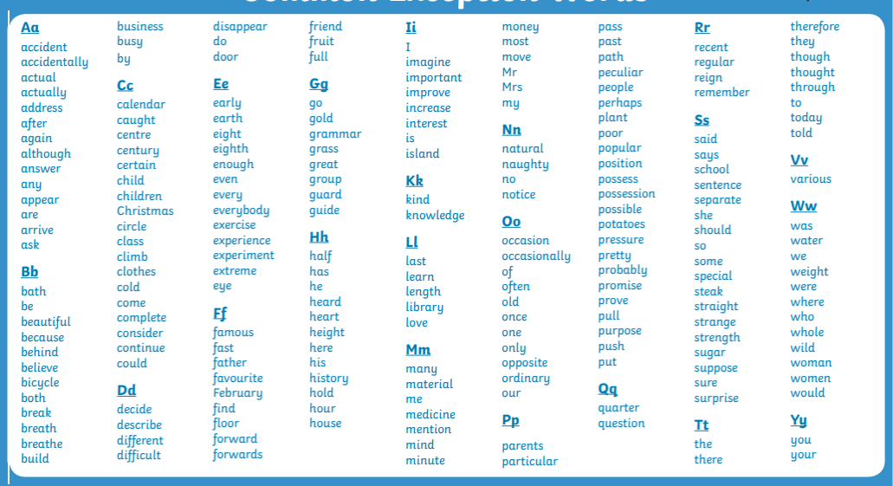

Here are a list of the common exception words from Y1, 2, 3, 4. In September we will be testing your reading and writing of these words. Over the holidays have a practice reading and spelling them yourself. Tick the ones you can do and highlight/concentrate on the ones you are finding tricky.

