
Parables What stories did Jesus tell?

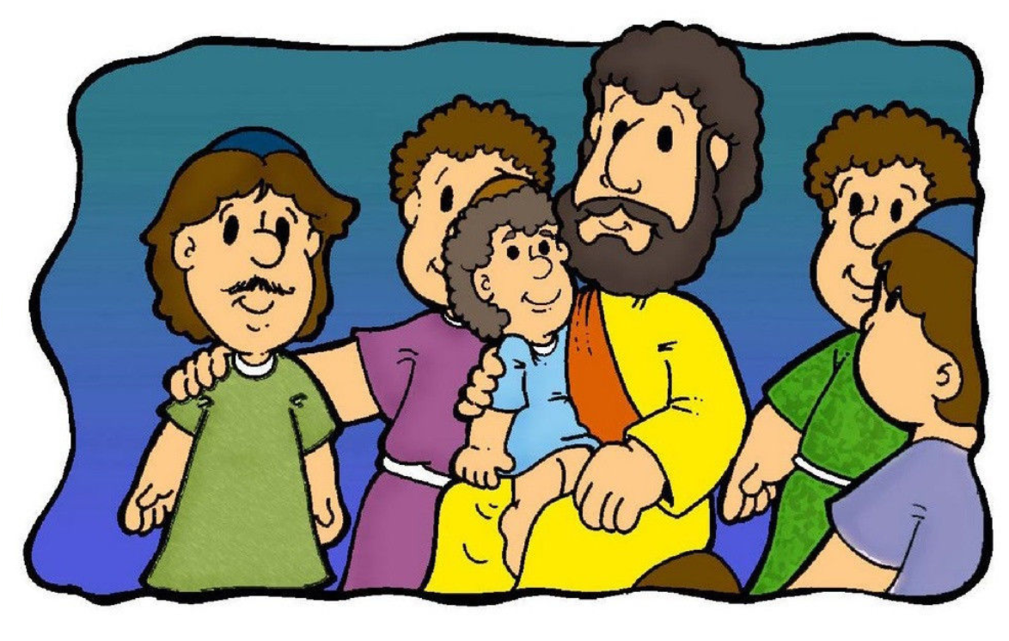
Contents
2. Key Words

3. Ideas for Early Years

4. Websites

5. The Parable of the Two Builders

11. The Good Samaritan

16. The Parable of the Sower

21. The Parable of the Lost Sheep

25. The Parable of the Lost Son

Parables
Parables were stories that Jesus told with a meaning. Jesus was an amazing storyteller and these stories were linked to the everyday lives of his listeners. These stories (parables) were about the Kingdom of God; they showed people how to behave, how to treat others and how to pray.

Key Words
parable | A short story with a meaning.
compassion | Think about how someone else is feeling; put yourself in their shoes.
endurance | To keep going, even when things are hard.
forgiveness | To let go of anger towards someone.
hope | Christians are a confident that God is faithful and will finish what He started.
thankfulness | Being content and saying thank you for what you have.
peace | Living well together; being free; quiet and calm.

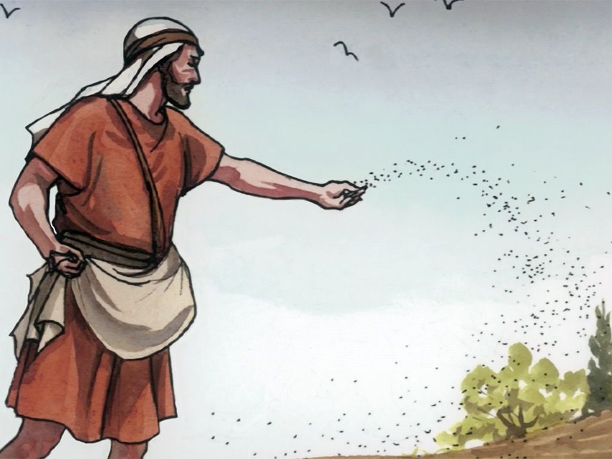

Make finger puppets from cereal boxes.
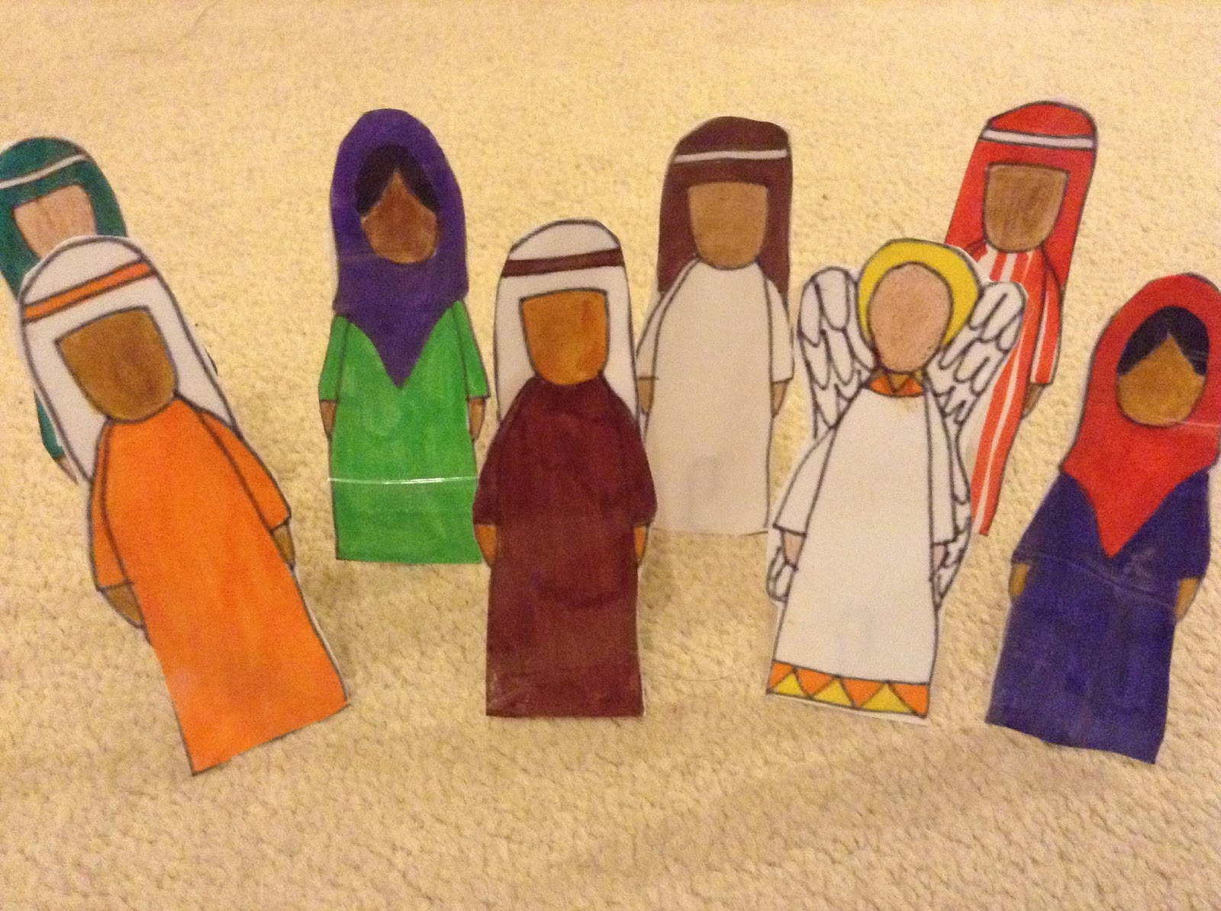
.Make and use play dough story characters
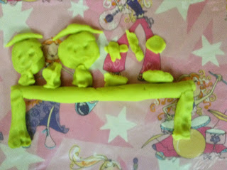
Create collages for characters and parts of the stories.


Use soft toys to retell any of the stories.

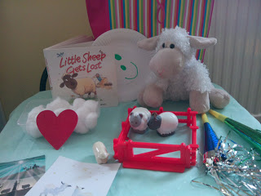
Use toys and household items to make story bags.

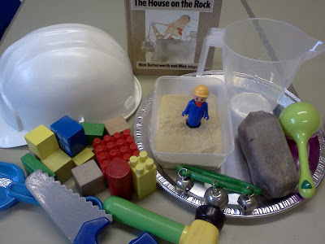
Build houses from any bits and bobs/recycling from around the house.
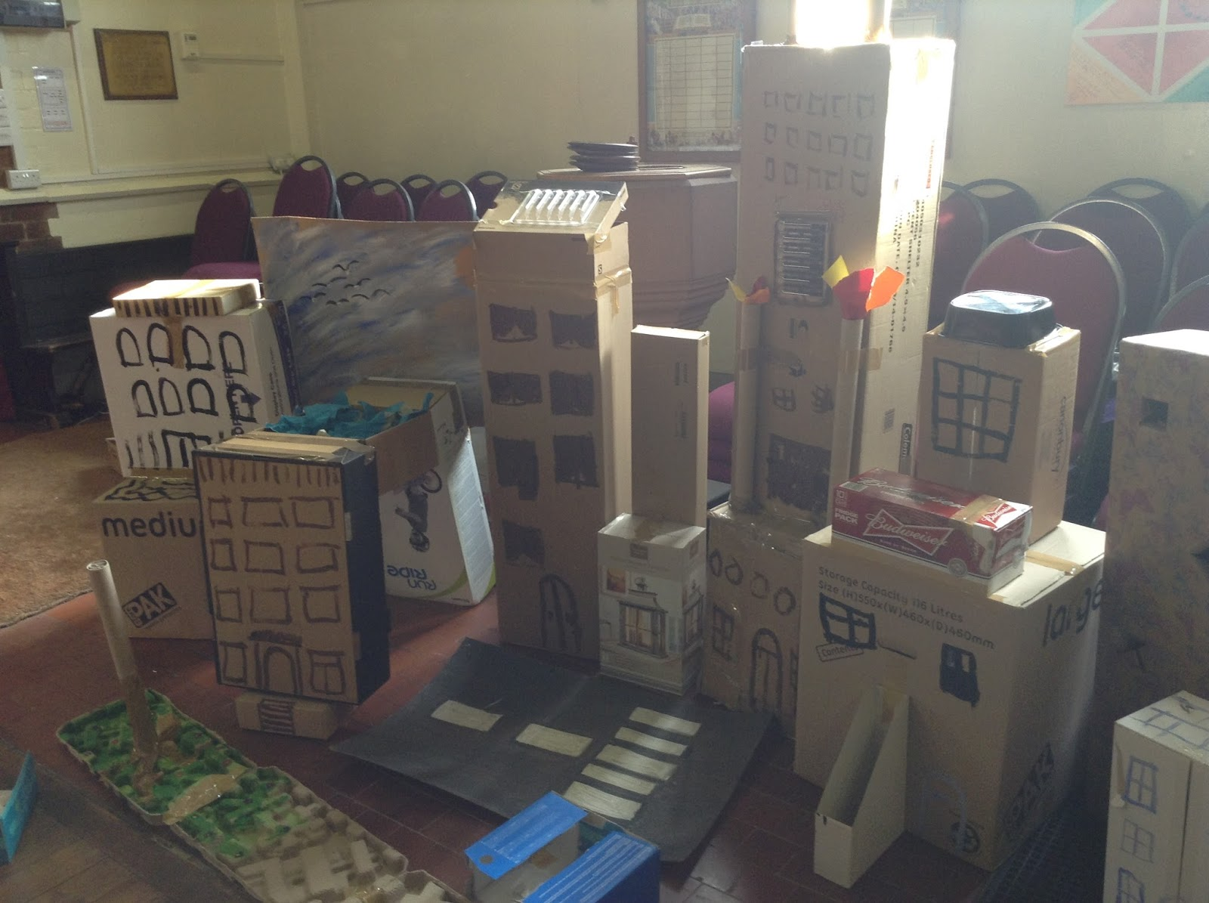
Ideas for Early Years

Websites
Flame Ministries http://flamecreativekids.blogspot.com/p/things-to-do-at-home.html
Pinterest https://www.pinterest.co.uk/scripturelady/bible-parables-for-kids/
RE Quest http://request.org.uk/jesus/parables/

The Parable of the Two Builders


Read ²⁴ “Everyone who hears these things I say and obeys them is like a wise man. The wise man built his house on rock. ²⁵ It rained hard and the water rose. The winds blew and hit that house. But the house did not fall, because the house was built on rock. ²⁶ But the person who hears the things I teach and does not obey them is like a foolish man. The foolish man built his house on sand. ²⁷ It rained hard, the water rose, and the winds blew and hit that house. And the house fell with a big crash.”
Matthew 7 24:27



Build houses out of some different things in your house. E.g. Lego, old boxes, playdough, tins
  - Which was house was the strongest?
  - Can you tell someone why?

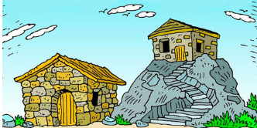
Tell the story to somebody at home. Make up names for the builders.

Watch a video of the story https://www.youtube.com/watch?v=CXWHLB1f6_U


Create a comic strip to retell the story.
Use speech and thought bubbles to show how the builders felt.

Christians follow Jesus’ teachings to show them how to live. These are the firm foundations. They try to show these values in their lives:
Love, kindness, compassion, forgiveness, endurance




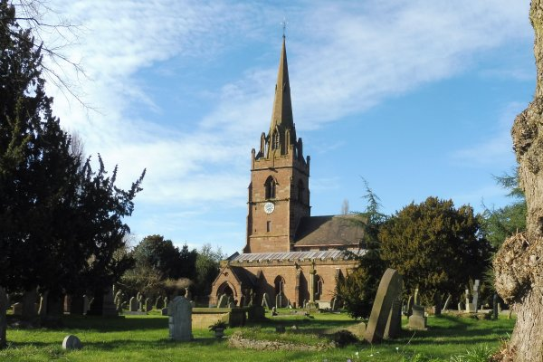
Find out about some of the things local churches do in the community. Write down your findings in the box below.

CHALLENGE: Make a poster for a local church which shows how they ‘live out’ the teachings of Jesus.

Think about the school values/Christian values.
Create a recipe for the best way to live:
A dash of
A tablespoon of
A cup of
A splash of



Create a Mandala Stone https://www.youtube.com/watch?v=UNnvvDQ0GFE
The initial black circle can represent your life.
The white dot in the centre can represent the thing / person that is at the centre of your life (e.g. .faith, education, love, family).
Each colour after that can represent the things that are our strong foundations (e.g. blue = family, green = honesty, yellow = laughter, pink = kindness…)


The Good Samaritan

Who is your neighbour? Write the name people who you think are your neighbours in the circles around you.

Me

Read ²⁵ Then a teacher of the law stood up. He was trying to test Jesus. He said, “Teacher, what must I do to get life forever?”
²⁶ Jesus said to him, “What is written in the law? What do you read there?”
²⁷ The man answered, “Love the Lord your God. Love him with all your heart, all your soul, all your strength, and all your mind.” Also, “You must love your neighbour as you love yourself.”
²⁸ Jesus said to him, “Your answer is right. Do this and you will have life forever.”
²⁹ But the man wanted to show that the way he was living was right. So he said to Jesus, “And who is my neighbour?”
³⁰ To answer this question, Jesus said, “A man was going down the road from Jerusalem to Jericho. Some robbers attacked him. They tore off his clothes and beat him. Then they left him lying there, almost dead. ³¹ It happened that a Jewish priest was going down that road. When the priest saw the man, he walked by on the other side of the road. ³² Next, a Levite came there. He went over and looked at the man. Then he walked by on the other side of the road. ³³ Then a Samaritan travelling down the road came to where the hurt man was lying. He saw the man and felt very sorry for him. ³⁴ The Samaritan went to him and poured olive oil and wine on his wounds and bandaged them. He put the hurt man on his own donkey and took him to an inn. At the inn, the Samaritan took care of him. ³⁵ The next day, the Samaritan brought out two silver coins and gave them to the innkeeper. The Samaritan said, ‘Take care of this man. If you spend more money on him, I will pay it back to you when I come again.’”
³⁶ Then Jesus said, “Which one of these three men do you think was a neighbour to the man who was attacked by the robbers?”
³⁷ The teacher of the law answered, “The one who helped him.”
Jesus said to him, “Then go and do the same thing he did!”
Luke 10: 25-37

The Good Samaritan
Watch a video of the story: https://www.bbc.co.uk/bitesize/clips/zcyr87h

What is happening in the pictures below? How do the people feel?

Look at the goodies and baddies. Who would you expect to be the helper in the situations above?

Look the pictures below. Who are the goodies? Who are the baddies?




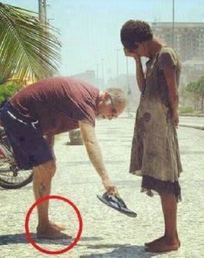

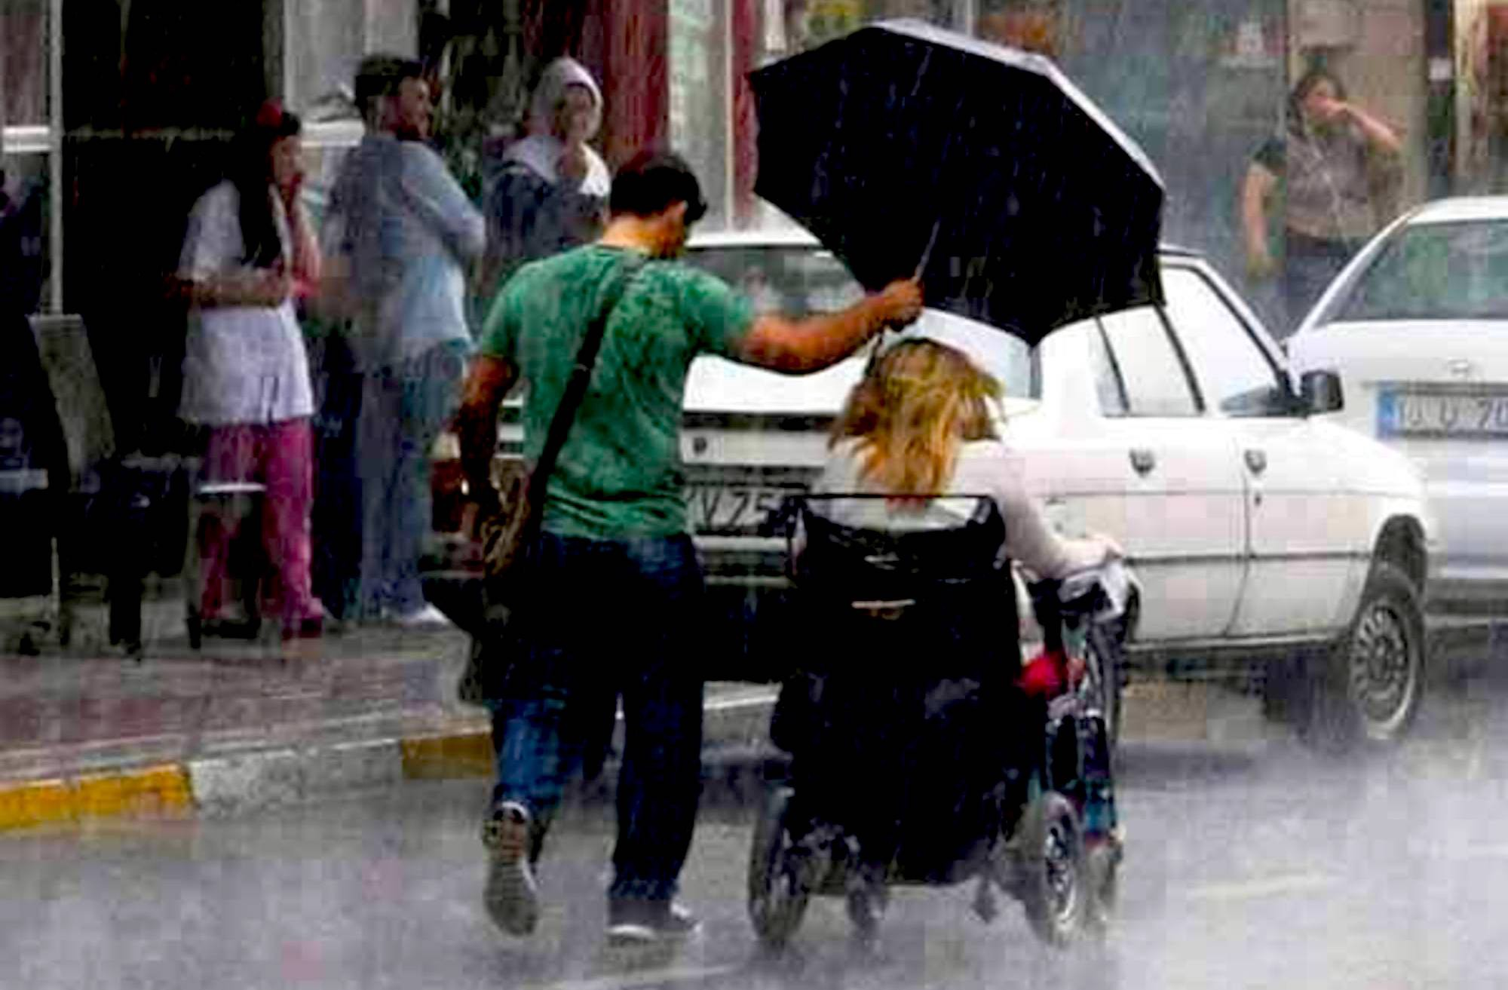



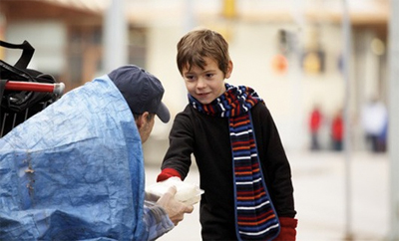

Christians believe that charitable work is one way of loving your neighbour. Look at the following website:
https://www.toilettwinning.org/

What does this charity do?


Who does the charity help?

What could you do to help your neighbours or make a difference in their lives?
Write or draw your ideas

The Parable of the Sower
³ “Listen! A farmer went out to plant his seed. ⁴ While the farmer was planting, some seed fell by the road. The birds came and ate all that seed. ⁵ Some seed fell on rocky ground where there wasn’t much dirt. The seed grew very fast there because the ground was not deep. ⁶ But when the sun rose, the plants withered. The plants died because they did not have deep roots. ⁷ Some other seed fell among thorny weeds. The weeds grew and choked the good plants. So those plants did not make grain. ⁸ Some other seed fell on good ground. In the good ground, the seed began to grow. It grew and made a crop of grain. Some plants made 30 times more grain, some 60 times more grain, and some 100 times more grain.”
⁹ Then Jesus said, “Let those with ears use them and listen!”
Mark 4: 3-12

What do you think the story means? Talk to an adult about your ideas.
Watch a video of the story
https://www.youtube.com/watch?v=tdl30y2Io-Y&feature=youtu.be
The Parable of the Sower

Background information: This parable explains how different people respond to the message and teaching of Jesus. It describes seed falling on four types of ground. The seed and its subsequent growth, or not, symbolises how people respond to the message of Jesus.
v4: Seed falling on the path and eaten by birds. Symbolises people hearing the message but ignore it.
v5-6: Seed falling on stony ground that sprouts quickly but the roots are shallow. The sun soon withers the plant and it dies. Symbolises those that hear the message, act with enthusiasm but as soon as things get hard they turn away and go back to their old ways.
V7: Seed falling amongst thorn bushes grow but get choked by the weeds and thorns. Symbolises those that are distracted by the world around them e.g. money, status etc. and then turn away from the message.
v8: Seed falling on good ground grows productively and yields fruit.
v9-12: People have a responsibility to hear the message of Jesus and to obey.

Christianity was once a secret religion which was outlawed and despised by the Roman culture at the time. It was difficult to follow the teachings of Jesus so early Christians would meet in secret and use secret signs and symbols.

Design your own secret symbol in the box below.

Chi-Rho

Icthus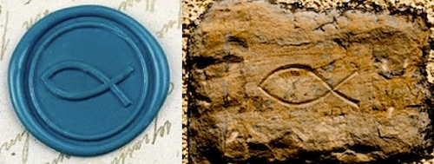

It is not always easy to follow good advice. Sometimes there are challenges which make it difficult to do the right thing.
Did you? If not, what stopped you?
Have you ever wanted to give up?
What things have you found difficult?

Think about what they did. What did they find difficult? What made them keep going?
CHALLENGE: Write an article about a famous Christian or someone from another faith who never gave up even when it got hard. E.g. Martin Luther King, Nelson Mandela, Mother Teresa, Gandhi, Malala Yousafzai.

Read: Many tax collectors and “sinners” came to listen to Jesus. ² The Pharisees and the teachers of the law began to complain: “Look! This man welcomes sinners and even eats with them!”
³ Then Jesus told them this story: ⁴ “Suppose one of you has 100 sheep, but he loses 1 of them. Then he will leave the other 99 sheep alone and go out and look for the lost sheep. The man will keep on searching for the lost sheep until he finds it. ⁵ And when he finds it, the man is very happy. He puts it on his shoulders ⁶ and goes home. He calls to his friends and neighbours and says, ‘Be happy with me because I found my lost sheep!’ ⁷ In the same way, I tell you there is much joy in heaven when 1 sinner changes his heart. There is more joy for that 1 sinner than there is for 99 good people who don’t need to change.
Luke 15:1-7

The Parable of the Lost Sheep
Who do you think is the ‘lost sheep’?
Watch a video of the story
https://www.youtube.com/watch?v=tyWZeOlaRo4

Have you ever been lost?
How did you feel?
How did your parents or carers feel when you were found?
Christians believe God is a father who will not give up on His people.
What jobs do fathers do? Write or draw your ideas in the box below:

Who do you think God cares for? Write or draw your ideas.

CHALLENGE: Create your own modern-day parable of the ’Lost Sheep’ in any way you choose. You could create a comic strip, story board or map, or even tell the story and record yourself doing it.

Which people in your local area are ‘lost’ or don’t fit in? Design a poster to show ways of helping these people.

What do you think is happening in the painting? Write your ideas around the picture.

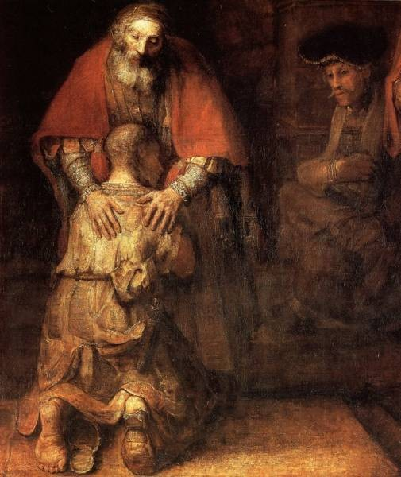

Read: ¹¹ Then Jesus said, “A man had two sons. ¹² The younger son said to his father, ‘Give me my share of the property.’ So the father divided the property between his two sons. ¹³ Then the younger son gathered up all that was his and left. He travelled far away to another country. There he wasted his money in foolish living. ¹⁴ He spent everything that he had. Soon after that, the land became very dry, and there was no rain. There was not enough food to eat anywhere in the country. The son was hungry and needed money. ¹⁵ So he got a job with one of the citizens there. The man sent the son into the fields to feed pigs. ¹⁶ The son was so hungry that he was willing to eat the food the pigs were eating. But no one gave him anything. ¹⁷ The son realised that he had been very foolish. He thought, ‘All of my father’s servants have plenty of food. But I am here, almost dying with hunger. ¹⁸ I will leave and return to my father. I’ll say to him: Father, I have sinned against God and against you. ¹⁹ I am not good enough to be called your son. But let me be like one of your servants.’ ²⁰ So the son left and went to his father.
“While the son was still a long way off, his father saw him coming. He felt sorry for his son. So the father ran to him, and hugged and kissed him. ²¹ The son said, ‘Father, I have sinned against God and against you. I am not good enough to be called your son.’ ²² But the father said to his servants ‘‘Hurry! Bring the best clothes and put them on him. Also, put a ring on his finger and sandals on his feet.

The Parable of the Lost Son

The Parable of the Lost Son
Read: ²³ And get our fat calf and kill it. Then we can have a feast and celebrate! ²⁴ My son was dead, but now he is alive again! He was lost, but now he is found!’ So they began to celebrate.
²⁵ The older son was in the field. As he came closer to the house, he heard the sound of music and dancing. ²⁶ So he called to one of the servants and asked, ‘What does all this mean?’ ²⁷ The servant said, ‘Your brother has come back. Your father killed the fat calf to eat because your brother came home safely!’ ²⁸ The older son was angry and would not go in to the feast. So his father went out and begged him to come in. ²⁹ The son said to his father, ‘I have served you like a slave for many years! I have always obeyed your commands. But you never even killed a young goat for me to have a feast with my friends. ³⁰ But your other son has wasted all your money. Then he comes home, and you kill the fat calf for him!’ ³¹ The father said to him, ‘Son, you are always with me. All that I have is yours. ³² We had to celebrate and be happy because your brother was dead, but now he is alive. He was lost, but now he is found.’”
Luke 15:11-32

What is the father thinking?
What is the son thinking?
Write your ideas in the thought bubbles.

Who was your favourite character?

Christ
What might the story teach Christians about what God is like?
How did the story make you feel?
What surprised you about the story?
What do you think was the most important moment?
Christian prayers have four main types: praise, saying sorry, saying thank you and asking for something.
Peter Praise
Suzy Sorry
Thea Thanks
Andrew Ask



The story of the Lost Son might lead Christians to think it very important to say ‘Peter Praise’ prayers and ‘Suzy Sorry’ prayers.
What might a Christian say in a time of prayer? Have a go at writing your own prayer.
Inside the parent/carer, draw or write what parents/carers do to show they love their children.
Inside the child, draw or write what children do to show they love their parent/carer.


The story of the ‘Lost Son’ teaches Christians that God is loving and forgiving like a parent.

What happens in school if you do something wrong? How do you have a fresh start?
What happens at home?

Write or draw examples of forgiveness.

Draw or write your ideas.
CHALLENGE: Think about a time when somebody hurt you. Is it good to forgive people? Why/why not? How does it feel when you don’t forgive? Why is it sometimes hard to forgive?

Door (Connection) – think about what have learnt. How could this impact how we think and act? This could be a very practical activity

